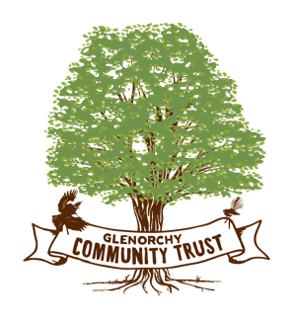
15 August 2026

The Glenorchy Community Trust has modernised and updated its website and added some new features. In the future people will be able to donate to the Trust either for particular causes or to make a general contribution to the work we do. From time to time we will update the trust with a report that we give to the Charities Commission which shows how we spend the money and how it is audited.
We hope you enjoy the new website glenorchycommunitytrust.co.nz

Nga mihi

Paul Ferris
Chair

