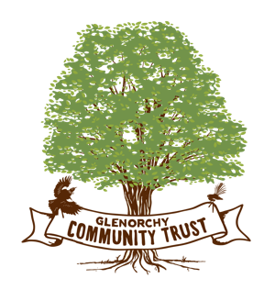September 2025

2nd Funding Round for 2025

Community Groups who might be thinking of applying for funds from the Glenorchy Community Trust in the December round of grants should begin to consider the project and the steps needed to have the information available for the application at the end of November 2025. Funding is limited to a maximum of $5000.00 for any one grant and groups that have received funding recently might have a lower priority than newer projects which have not previously been supported. All applications should be made through the trust website. If there are issues with the application process please advise quickly so the software can be reset.

Any group wishing to discuss an application prior to submission should feel free to contact any member of the trust or me on 0274898822.

Nga mihi

Paul Ferris

Chairman