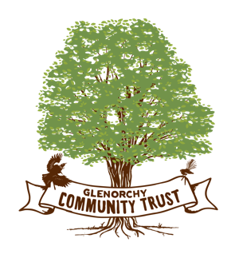

The Community Trust met before Easter to consider the largest number of requests for funding in the history of the trust. A total of $19,500.00 was granted and requests for more information were made to various groups so that their applications could be considered.

The following activities were supported in the latest round of funding:

Red Shed Productions.

Sustainable Glenorchy

Tahuna Glenorchy Dark Skies Sanctuary

Glenorchy Trails Trust

Glenorchy Community Website upgrade

Glenorchy Collective Trust

Further information was sought from the Glenorchy Community Association and the Glenorchy Golf Club.

Thank you to all the Community Groups who submitted applications. The next funding round will close in November.

Paul Ferris

Chair.