Predator Free New Zealand
What Does it Mean and Why Should We Care?
Catalyst Kōrero, 6-7.30pm, Tuesday, March 26
New Zealand is the only country in the world that has turned pest eradication into an export industry, says renowned conservationist David Bellamy – and yet many of our native species are still gravely at risk from rats, mice, stoats and other introduced pests.
What can we do about it? What happens if we don’t? Why should we care? And why is biodiversity so important anyway?
These are some of the questions three local experts will cover from local, national and international perspectives, in our March 26 Catalyst Kōrero.
In Queenstown Lakes, some 1000 volunteers are the major backstay of predator elimination work in the 163,000 ha of Southern Lakes Sanctuary’s back country.
Starting just two years ago, the original consortium of six groups now supports around 100 volunteer groups. Some of which had already been operating, but in isolation, for over 25 years.
Collaborative efforts in conservation have already led to the return of takahē chicks by the Department of Conservation onto Ngāi Tahu’s Greenstone Station in August, 2023. SLS project director Paul Kavanagh says they are working hard to prepare the Rees Valley for a potential further release next year.
Takahē had previously been declared extinct and he admits returning endangered species to the wild is a risk. “But one worth taking, as Aotearoa’s sanctuaries are reaching saturation point.”
The former Kiwi Birdlife Park manager will be speaking alongside Ange Newport, the Department of Conservation’s conservation programme senior adviser and detection dog trainer, and Keith ‘Spang’ Springer, now operations manager for Birdlife South Africa’s Mouse Free Marion Project.
Ange has been training and working with conservation dogs around New Zealand for some 15 years. She trains different dogs for feral cat, mustelid, rodent and possum control. They are trained to track and identify, not kill.
Spang has been involved in pest eradication and animal control work for 35 years, moving from mainland pest control to mainly island pest eradication programmes around the world since 2006.
Tuesday, March 26, 6 to 7:30 pm at the Rees hotel Queenstown’s conference room. Registration is required, as seats are limited. Please bring cash for your koha, which will be given to Southern Lakes Sanctuary.
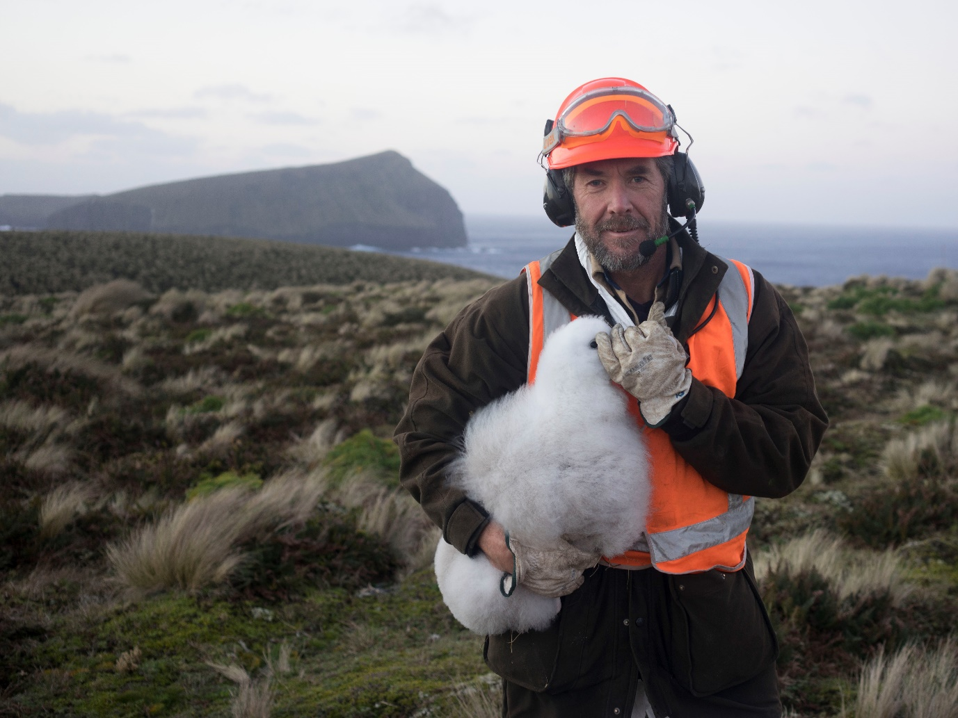
Keith – Spang – Springer
Paul Kavanagh

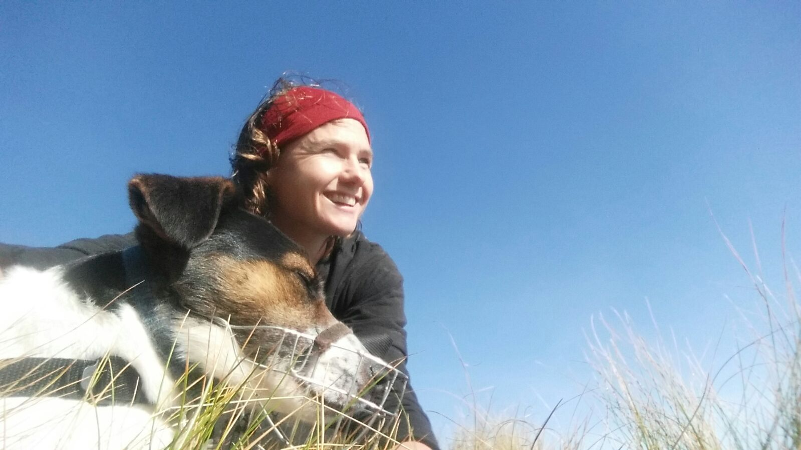
Ange Newport

