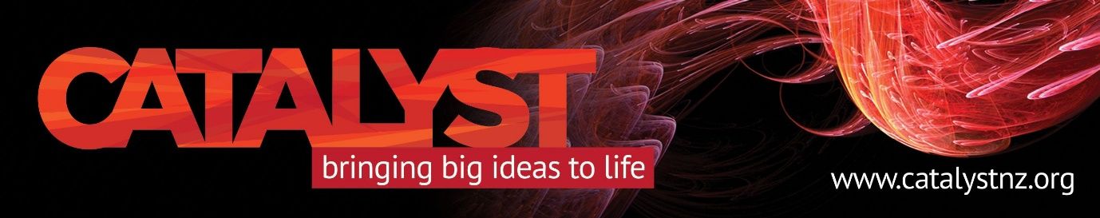

“Hate Speech in the Age of the Internet: Challenges for All of Us”
A Catalyst Trust Conversation

The Christchurch Mosque terrorist attack has made the significance of hate speech in the age of Internet horrifically clear. Distinguished Prof Paul Spoonley is a demographer of national renown who has extensively researched factors behind hate speech and recently chaired a government agency group on this “extremely challenging issue”.

What qualifies as hate speech and who decides? What does it do to respectful and positive relations among our communities? Can it be controlled, and if so, how?

“When I began to research the issue and its extent, I was appalled at how much there was and the degree to which racial and religious vilification played a part. I have studied anti-Semitism but what struck me was how extensive Islamophobic comments were, including from New Zealanders.

“And I was also struck by how particular groups – ethnic/religious minorities, youth – were impacted. The Christchurch terrorist attack has brought the significance of all this home. What lessons might we – as a society, community and individuals – learn?”

Thursday, April 4, 6-7.30pm, at The Rees Hotel Queenstown conference room, $5 koha at door. Registration is required as seating will be limited, with tickets available through Catalyst Trust’s Eventbrite page. Please bring your tickets (printed, emailed or Eventbrite app).

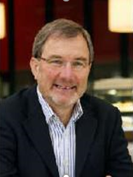

Prof Spoonley is the Pro-Vice-Chancellor of the College of Humanities and Social Sciences at Massey University. He is a leading demographer involved in major research projects on immigration and diversity in NZ. He is the author or editor of 27 books and a Fellow of the Royal Society of New Zealand. His original research was on anti-Semitism and the extreme right in New Zealand.

