Fish & Game want gain a better understanding of catch rates and how the fishery is performing.
Even if you didn’t catch a fish please complete this form and place it in the labelled Fish & Game collection box at the weigh-in station.
Boat or group anglers please provide information for all participating anglers (fill out one row for each angler).
Name  Boats or groups use 1 line per angler | Hours Fished  nearest ¼ hr  e.g 1.25 hrs | Fishing method  (see the method key below) | No. of Fish  Kept |  | No. of Fish Returned
 |  |  | Brown |  | Brown
 |  |  | Rainbow |  | Rainbow
 |  |  | Salmon |  | Salmon
 |  |  | Brown |  | Brown
 |  |  | Rainbow |  | Rainbow
 |  |  | Salmon |  | Salmon
 |  |  | Brown |  | Brown
 |  |  | Rainbow |  | Rainbow
 |  |  | Salmon |  | Salmon
 |  |  | Brown |  | Brown
 |  |  | Rainbow |  | Rainbow
 |  |  | Salmon |  | Salmon
 |  |  | Brown |  | Brown
 |  |  | Rainbow |  | Rainbow
 |  |  | Salmon |  | Salmon
All completed entries will go into a draw for spot prize!

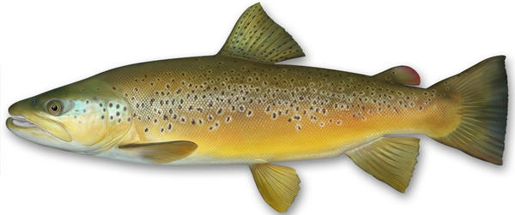
Brown trout have no spots on their tail and they can have distinct spots on the gill cover and on their side. In lakes they can appear more silver than golden (as shown).

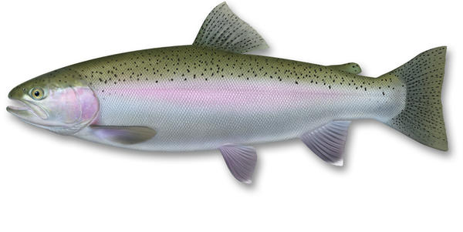
Rainbow trout have distinguishing spots on their tail and can get a reddish stripe along the side and gill plate around their spawning time. As with browns and salmon they can be very silvery, but the tail spots are the main feature.

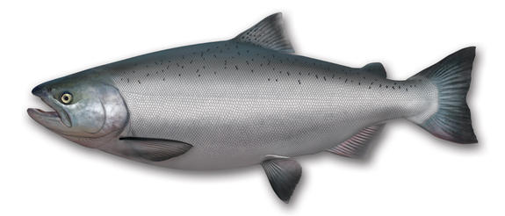
Chinook salmon are very silvery, and their scales will stick to your hands when the fish is handled. Key distinguishing features include:
- grey/black gums
- generally a forked tail (particularly pronounced in landlocked lake salmon). Tail has spots and may also appear fluorescent
- narrow caudal peduncle (base of tail)
- 14 – 19 anal fin rays (fin underside of the fish, closet to tail) compared to brown and rainbow trout which have 8 – 12

