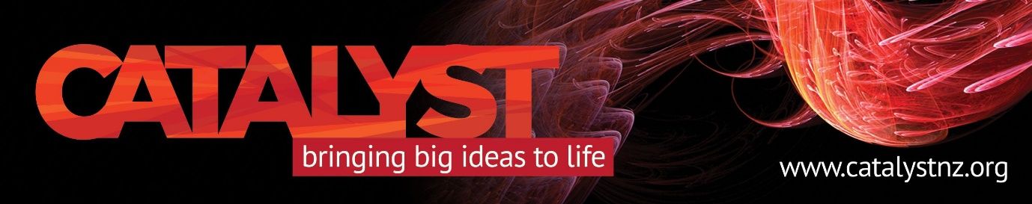

1984’s Big Brother is here and sitting in your pocket…
Mobile Phone and Internet Security
Tuesday, March 27, 7 to 8:30 PM

Cambridge Analytica is just one insidious symptom of the “surveillance capitalism” started by Facebook in 2002, says Catalyst Trust’s Tuesday night speaker, Dr Henry Wolfe.
Adds the IT specialist and former CIA operative; “If you use Facebook or Google or Windows 10, understand this – YOU are the product.”
The effects of data mining from Facebook has hit the headlines recently, with Cambridge Analytica (and its clients) accused of trying to swing electoral results and policies across the globe.
Dr Wolfe says we are “totally mistaken” if we think we’re protected by standards, statutes and privacy laws from security risks on our ubiquitous mobile phones. “We are not.”
The University of Otago lecturer is known internationally for his work on electronic forensics, encryption, surveillance, privacy and computer virus defences. He has trained NZ, Australian and Singaporean police in electronic forensics.
He will outline how far phone and Internet company tentacles stretch into our lives and how (if you want) to limit that reach – in language even non-digital natives can understand - followed by Q & A.
The Rees Hotel Queenstown conference room, $5 koha at door, please register at connect@catalystnz.org to ensure your seat.

